SKILLEX WEB 2020

Secure Voting Online



Prepared by:

Stream: **B.TECH C.S.E**

Year: **4th Year**

**Name:**  **Roll No:**

Debabrata Bhattacharya 161112015005

Poulamee Thakur 161212015009

Trisha Ghosh 161212015014

Soumya Dutta 161112015020

**Date**: 30/04/20

**Institute**: JIS University

**Prepared for:**

**SkillEx WEB 2020**

Table of Contents

ACKNOWLEDGEMENT 4

Chapter 1: Introduction 5

1.1 Existing problems with electronic voting 6

1.2 Our System 6

Chapter 2: Steps To Be Followed 7

Chapter 3: Technologies Leveraged 8

3.1 Gmail: 8

3.2 Android operating system: 8

3.3 Zxing 8

3.3.1 Supported Formats 9

Chapter 4: Advantages 10

Chapter 5: Target Audience 11

Chapter 6: Screen Shots 12

6.1 Voting form 12

6.2 App Screenshots 13

Chapter 7: Future Scope 15

Chapter 8: Conclusion 16

REFERENCES 17

ACKNOWLEDGEMENT

We would like to express our special thank of gratitude to our teachers who gave us the opportunity to make this project on the topic **SECURE ONLINE VOTING**, which helped us in doing a lot of research and we came to know about many new things so we are very thankful to them.

# Introduction

Voting is a right to every citizen. It gives the choice of the people to whom they want to up hold the meaning of a system governed by the people’s choice. However, representing elections have become a debatable issue. Different techniques of voting have evolved from simple manual voting to internet voting systems that only require the voter to come from the comfort of their home to vote their candidate from their personal computers. An election system should be able to overcome different hacking and fraud techniques. To overcome different complications and to reinforce the checking and calculating results, the project suggests the use of hashing. Authentication is made by comparing hashes using SHA-256. The system is more secured. Vote can be audited later by comparing hashes in a database.

Online voting or E-voting refers to voting using electronic means to either aid or take care of the chores of casting and counting votes.

Depending on the particular implementation, e-voting may use computers connected to the internet. It encompasses a range of Internet services, from basic data transmission to full-function online voting through common connectable consumer devices.

The proliferation of personal mobile devices in the form of tablets and smartphones, based on the Android operating system, presents a unique opportunity to empower isolated communities who traditionally have had a difficult time voting.

## Existing problems with electronic voting

* Lack of paper trail limiting auditing options.
* Insecure application design vulnerable to State and Non-State actors.
* Difficulty in authenticating voters on Election Day.

## Our System

Relevant agencies tasked with conducting the election shall make use of the National Electoral Roll database and send all registered voters a letter with information about the voting process.

The user opens the app and scans 2 pieces of information from the letter:

1. Information that authenticates him and his vote

2. The code that indicates his vote

These two pieces are not stored but immediately collected by the Google Gmail App. A ready-to-send email is generated with the two pieces of information. The user can then send the email. Gmail's built in header auditing and caching infrastructure will ensure that the email reaches its destination safe from malactors such as hackers, phishers, etc.

The government can then audit the vote itself with the relevant information provided, ensuring a reliable and rigorous election.

# Steps To Be Followed

1. User receives a letter with scan-able information.
2. User opens the app and scans his own information as well as the candidate he chooses to vote for.
3. An email in the Gmail App is automatically generated with encrypted data.
4. The user sends this email.
5. Email received is used to count votes for candidates.
6. The received email is verified and will count as a single vote.
7. The vote can be audited by verifying hashed user information.

# Technologies Leveraged

## Gmail:

Gmail is a zero-price, advertising-supported email service developed by Google. Users can access Gmail on the web and through mobile apps for Android and iOS, as well as through third-party programs that synchronize email content through POP or IMAP protocols. Gmail has one billion active users worldwide, and according to a Radicati Group study from January 2017, there will be more than 3.7 billion email users worldwide by the end of the year.

Google's mail servers automatically scan emails for multiple purposes, including to filter spam and malware. Gmail's spam filtering features a community-driven system: when any user marks an email as spam, this provides information to help the system identify similar future messages for all Gmail users.

As such, Gmail is contextually effective infrastructure in pursuit of secure online voting.

## Android operating system:

Android is a mobile operating system developed by Google, based on the Linux kernel and designed primarily for touch screen mobile devices such as smart phones and tablets.

Android's user interface is mainly based on direct manipulation, using touch gestures that loosely correspond to real-world actions, such as swiping, tapping and pinching, to manipulate on-screen objects, along with a virtual keyboard for text input. In addition to touch screen devices,

Android applications ("apps") can be downloaded from the Google Play store, which features over 2.7 million apps as of February 2017. Android has been the best-selling OS on tablets since 2013, and runs on the vast majority of smart phones. As of May 2017, Android has two billion monthly active users, and it has the largest installed base of any operating system.

## Zxing

ZXing ("Zebra Crossing") barcode scanning library for Java, Android.

ZXing ("zebra crossing") is an open-source, multi-format 1D/2D barcode image processing library implemented in Java, with ports to other languages.

### Supported Formats

| **1D product** | **1D industrial** | **2D** |
| --- | --- | --- |
| UPC-A | Code 39 | QR Code |
| UPC-E | Code 93 | Data Matrix |
| EAN-8 | Code 128 | Aztec (beta) |
| EAN-13 | Codabar | PDF 417 (beta) |
| UPC/EAN Extension 2/5 | ITF | MaxiCode |
|  |  | RSS-14 |
|  |  | RSS-Expanded |

# Advantages

1. The system can be used anytime and from anywhere by the Voters.
2. No one can cast votes on behalf of others and multiple times.
3. Saves time and reduces human intervention.
4. The system is flexible and secured to be used.
5. Unique Identification of voter through user info hashes.
6. Extremely secure system with one time password.
7. Improves voting with friendly Android Interface.
8. No fraud vote can be submitted.

# Target Audience

* Citizens who wish to vote in privacy of their homes
* Citizens who vote in violence-prone areas
* Citizens in remote areas who have difficulty in reaching voting stations
* Citizens who have difficulty in reaching voting stations due to lack of infrastructure in underdeveloped areas.

# Screen Shots

## Voting form

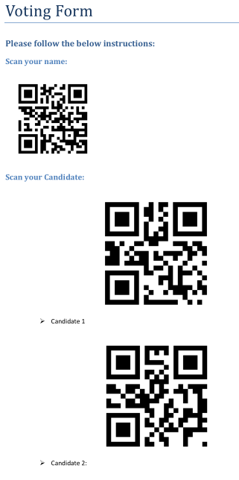

1. Voting form

## App Screenshots



1. Splash Screen

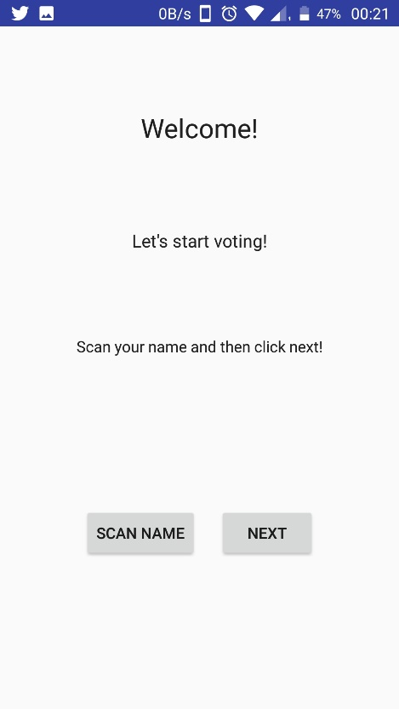

1. Welcome Screen

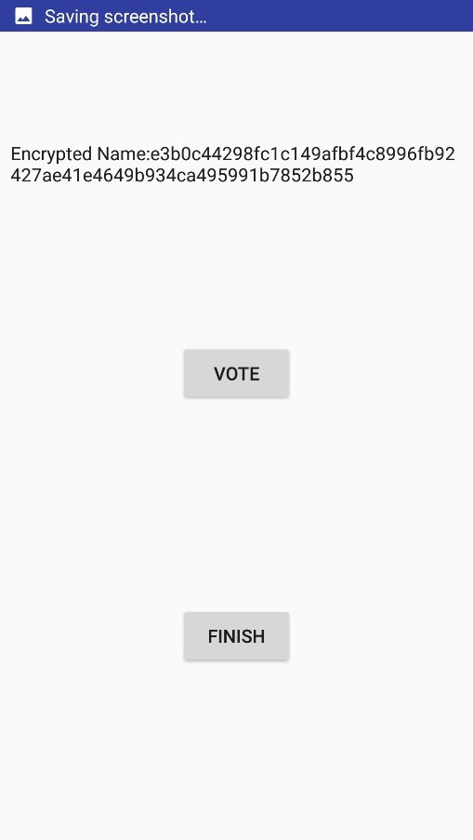

1. Voting Screen

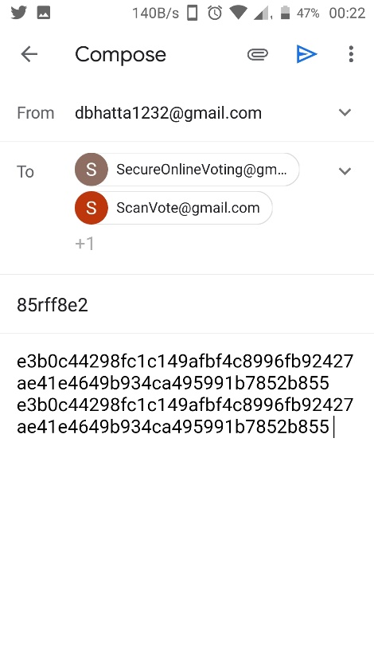

1. Email Screen

# Future Scope

* Integration of disability-friendly user interface.
* Client side and server side auditing of votes.

# Conclusion

Online Election systems have many advantages over the traditional voting system. Some of these advantages are less cost, faster generation results, easy accessibility, accuracy, and low risk of human and mechanical errors.

It is very difficult to develop e-voting system which can allow security and privacy on the high level. Future development focused to design a system which can be easy to use and will provide security and privacy of votes on acceptable level by proper authentication and processing section.

In case of online e-voting some authentication method like play fair cipher and unique voter id and aadhar card number is used. By online voting system percentage of voting is increases and cost and time of voting process is decreases.

It is easy to use and it is less time consuming. It is very easy to debug.

REFERENCES

* A.S. Belenky and R.C. Larson, “To Queue or not to Queue?” OR/MS 27, October 2013, pp.30-34.
* R. Krimmer (ed.), Electronic Voting, Proceedings of the 2nd International Workshop, Gesellschaft für Informatik, Bonn, Köllen Druck+Verlag GmbH, Bonn, October 2013.
* “An Electronic Polling Service to Support Public Awareness Using Web Technologies”, Christos Bouras, Nikolaos Katris, Vassilis Triantafillou.
* “E-voting on Android System” paper (International Journal of Emerging Technology and Advanced Engineering) prepared by : Kirti Autade, Pallavi Ghadge, Sarika Kale ,Co-authors- Prof. N. J. Kulkarni, Prof. S. S. Mujgond, February 2012.
* “Electronic voting,” Encyclopaedia of Computers and Computer History, prepared by Lorrie Faith Cranor and edited by Raul Rojas, published by Fitzroy Dearborn, 2001.
* “Voting – What is, what could be,” Caltech/MIT Voting Technology Project (VTP) Report, July 2001.
* “A Modular Voting Architecture (“Frogs”),” Shuki Bruck, David Jefferson, and Ronald L. Rivets, August 2001.
* “Comments of Professor Ronald LRivest”, Caltech/MIT VTP Press Conference, July 16, 2001, http://theory.lcs.mit.edu/~rivest/publications.html.
* “Testimony given before the U.S. House Committee on Administration”, Ronald L. Rivets, May 24, 2001, http://theory.lcs.mit.edu/~rivest/publications.html.
* “Electronic Voting,” Ronald L. Rivets, Technical Report, Laboratory for Computer Science, Massachusetts Institute of Technology